Faculty Exploratory Travel Proposal

University of North Georgia in London

Faculty-Led Short-term Study Abroad Program

Summer 2019

Proposal prepared for:
Pamela Newell, Professor
82 College Circle, 330 Hansford Hall
University of North Georgia
Dahlonega, Georgia 30597
Pamela.newell@ung.edu

Proposal prepared by:
Chuck Hermans, Travel Consultant
uAdventure, LLC Travel
The Hammons Tower
901 E. St. Louis St.
Suite. 200-9
Springfield, MO 65806
(417) 268-0891
adventuremaker@uadventuretravel.com

uAdventure, LLC Travel, 901 E. St. Louis St., Suite 200-14, Springfield, MO 65806, (417) 771-8885
adventuremaker@uadventuretravel.com
www.uAdventureTravel.com

Tentative Itinerary- London
Tuesday, August 13rd : Atlanta to London
3:00pm Arrive at Atlanta airport
5:54 pm: Flight: to London

Wednesday, August 14th
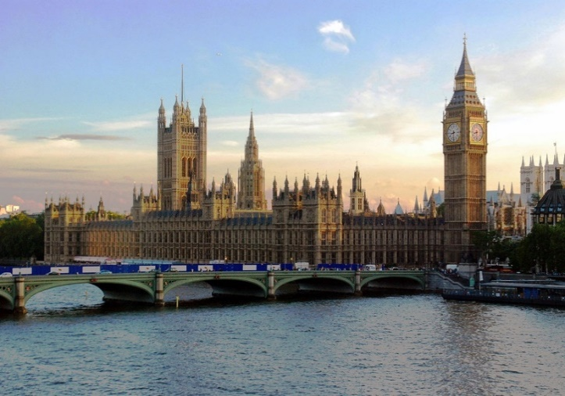
Arrive in London at LGW
Private Airport transfer
London Card and Oster Card – Tube and Bus Transportation 14th-17th

Visit the Tower of London. See the world-famous crown jewels at one of the world’s most famous fortresses. The tower has been used as a palace, prison, armoury, and even a zoo! Enjoy the views of the River Thames.

Suggested Lunch at Sargeant’s Mess. This classic British dining experience includes a view of Tower Bridge and the River Thames. (NIC)
Take the yellow route to Palace of Westminster

Tour of Parliament—discover where history is still being made in the Houses of Parliament! Optional afternoon tea to follow (at 2:00 or 3:45).
Walk to visit Big Ben and then Great Scotland Yard

Dinner at the Boyds Grill & Wine Bar
Return to Hotel

Thursday, August 15th

Old Bailey/Legal London tour

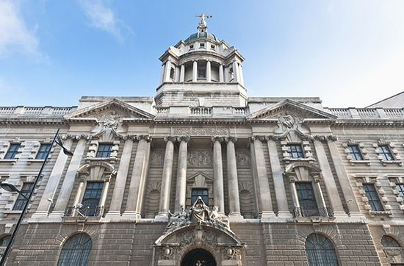
Suggested Lunch at Coco di Mama, fast, delicious Italian to-go! (NIC)

2:00 pm: Optional viewing of court proceedings until 4-4:30 pm

Free time to explore the area!

Jack the Ripper Tour (begins at 7pm)— take a walking tour, following in the footsteps of Jack the Ripper and his unfortunate victims in London’s East End. Visit the sites of his murders and learn more about the mysteries and rumors surrounding the unsolved serial crimes.

Friday, August 16th
Transfer to Granaio, 224 Piccadilly, St. James's, London W1J 9HP, UK
Sherlock Holmes Tour

Visit the City of London Police Museum

Free time to explore the area!

Suggested Dinner at Magpie & Stump, an English pub that’s been around for 500 years! This was a renowned “mughouse” in the 1700’s, where guests would visit, drink ale, and have a view of the hangings outside Newgate Prison. The pub would even send out a last pint to the condemned man before his execution! (NIC)

Saturday, August 17th
Free Day to explore London
Hop on Hop off Bus – See Westminster Abbey, The Tower Bridge, St. Pauls Cathedral, Kensington Palace, view from the Shard, all on your London Card.

Sunday, August 18th
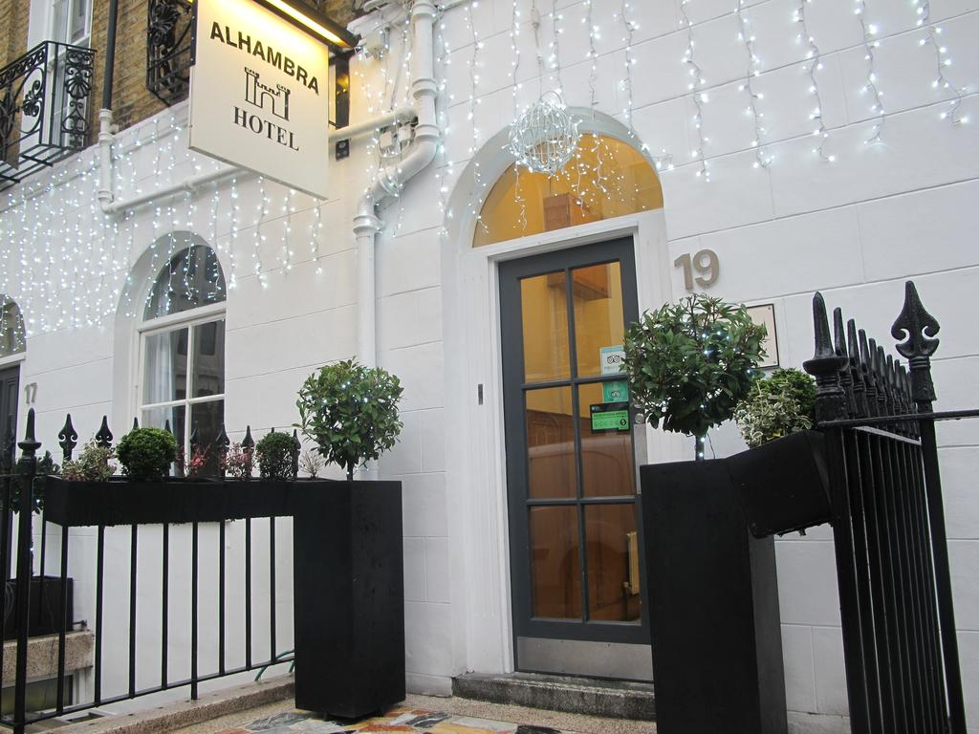
6:00 am: Check out and head to Airport
Private Airport Transfer
10:10 am: Delta flight to Hartsfield-Jackson Atlanta International Airport (ATL)

Hotel:
Alhambra Hotel (Twin with Breakfast)
17-19 Argyle Street, London GB WC1H 8EJ
2.01mi From (city centre)
Wed, 14 Aug, 2019 - Sun, 18 Aug, 2019
1 Room | 2 Adults
Very Good 2418 Reviews

Costs (subject to change and availability):
Pamela
Flights $1,084 per person
Hotel Room, Private Transfers and Tours $1,596 per person
Total $2,496
Sister
Flights $1,084 per person
Tours/tickets/London card/Oyster Card only for one additional person* $ 694
*(Shared room and nic transfers) Total $1,778

