Thank you for taking the time to price a Funjet Vacations getaway, where you'll Do Something You'll Never Forget, with UADVENTURE LLC. This email is to notify you of the items you selected when working with Michelle Hermans from UADVENTURE LLC. All prices listed may be subject to change until payment is received.
Consider upgrading your room for the best vacation experience!
Please review the Terms and Conditions.
Total Amount of Payments | USD $0.00
Balance Due | USD $4,766.81
Deposit Due on 22AUG19 | USD $461.98
Full Payment Due on 05SEP19 | USD $4,766.81

Flights - departing 20OCT19 and returning 27OCT19
Depart
United Airlines #5824 † Operated by :SKYWEST DBA UNITED EXPRESS |  |  | Bulk Fare Coach S
Leaves | Sunday, October 20, 2019 | 6:55 AM | Springfield, MO (SGF)
Arrives | Sunday, October 20, 2019 | 8:52 AM | Houston - Intercontinental (IAH)
Selecting new seat assignments temporarily unavailable. To select seats, contact your airline.
United Airlines #1014 |  |  | Bulk Fare Coach S
Leaves | Sunday, October 20, 2019 | 10:35 AM | Houston - Intercontinental (IAH)
Arrives | Sunday, October 20, 2019 | 12:45 PM | Cancun - Cancun AND Riviera Maya (CUN)
Selecting new seat assignments temporarily unavailable. To select seats, contact your airline.
Travel time: 5hr 50min

Additional baggage charges may apply
Return
United Airlines #1019 |  |  | Bulk Fare Coach W
Leaves | Sunday, October 27, 2019 | 3:17 PM | Cancun - Cancun AND Riviera Maya (CUN)
Arrives | Sunday, October 27, 2019 | 5:47 PM | Houston - Intercontinental (IAH)
Selecting new seat assignments temporarily unavailable. To select seats, contact your airline.
United Airlines #4333 † Operated by :EXPRESSJET AIRLINES DBA UNITED EXPRESS |  |  | Bulk Fare Coach W
Leaves | Sunday, October 27, 2019 | 7:55 PM | Houston - Intercontinental (IAH)
Arrives | Sunday, October 27, 2019 | 9:46 PM | Springfield, MO (SGF)
Selecting new seat assignments temporarily unavailable. To select seats, contact your airline.
Travel time: 6hr 29min

Additional baggage charges may apply
† indicates codeshare flight

Hotel - check in 20OCT19 and check out 27OCT19
El Dorado Seaside Suites, a Spa Resort by Karisma - All Inclusive
- Location: Riviera Maya
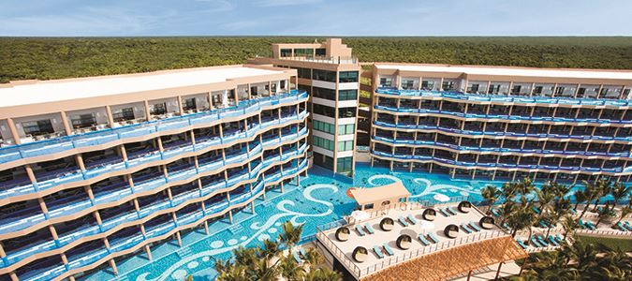Room 1 - 2 Adults
Room Type - Oceanfront Swim Up Suite
Save 63%!
Exclusive VIP Inclusions!
Guests will receive the following Inclusions.
- Guaranteed High floor room assignment
- Preferred seating in restaurants.
- A Gourmet Inclusive tasting Experience chosen by the Hotel.
- A daily Mexican delicatessen delivered at turn down service.
Important information: Further details will be provided at hotel check-in. Restrictions may apply.
Complimentary Wi-Fi and Free International Phone Calls!Guests will receive free Wi-Fi and free international phone calls.

Memorable Moments Honeymoon & Anniversary Package!Guests celebrating their honeymoon or anniversary will receive:
* Personal services of a Romance Maitre D
* Private gourmet four course candlelit dinner on the beach
* Romantically decorated suite with rose petals, aroma therapy, and candles following the private dinner
* Chef's special gourmet breakfast in bed the morning after dinner
* Beachfront sky massage 2 x 1 offer (cannot be combined with any resort credit offers)
* Chilled bottle of champagne delivered to room upon arrival
* 15% discount on spa services ( cannot be combined with any resort credit offers)
* Fresh tropical floral arrangement in room
Important Information: Copy of marriage certificate (or wedding invitation with wedding photo) required at check-in. Package can be reserved for use up to 90 days after wedding date for honeymoons and 30 days before and after wedding date for anniversaries. One massage must be purchased to receive one of equal or lesser value complimentary. Package inclusions may vary without previous notice. Not combinable with any other promotion unless otherwise specified. Only available when qualifying category is purchased. Not valid for any reservations traveling with a group or wedding party. Also not combinable with Taste of Romance offer.
Gourmet Inclusive Amenities The Gourmet-inclusive program includes the following amenities:
* Welcome glass of sparkling wine
* All gourmet meals and specialty bites
* Unlimited Local and selection of international premium brands, Alcoholic and non-alcoholic beverages
* Once daily restocked minibar with soft drinks, water, snacks and beers
* Daily and nightly activity program with live music and night entertainment
* Non-motorized water sports: kayak and snorkeling gear
* Beach Towel Service
* Bathrobes & slippers to use during your stay
* Scuba Clinics in the pool
* A hard surface tennis court (not lit). Rackets and balls provided free of charge at the front desk.
* Activites: Beach volleyball, aquaerobics, salsa lessons, seasonal yoga/stretching sessions
* Taxes and gratuities
Important Information: Redemption information will be provided by the hotel at check-in
Applicable promotions will display with your room selection. Some restrictions may apply.
Hotel Rating 5.0

Hotel Advisories
The Municipality of Solidaridad will be charging an Eco Tax of 20.00 Mexico Pesos (approx. $1.10 USD) per room per night. This amount is not included in your vacation price and will be collected at your hotel. These funds are being used to protect, maintain and conserve the natural beauty of the destination the area and its surroundings. Important Information For Our Guests Please be aware that due to changing weather and ocean conditions, beach shapes and characteristics may vary. Important Note: The beach in front of the hotel is a natural coral reef and is great for snorkeling. There is a modest section of beach that is suited for swimming and other water activities.

Add-ons - for 20OCT19 to 27OCT19
All-In-One Travel Protection
Date - Sunday, October 20, 2019
Price - 2 Adults $130.99 ea.

Chichen Itza Deluxe - Hotel Ground Transportation is Included
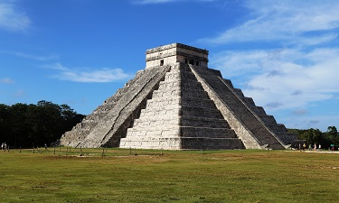
Date - Sunday, October 20, 2019
Price - 2 Adults $150.00 ea.

Identification Required For Travel
Date - Sunday, October 20, 2019
Price - Included with hotel

Price Match Plus
Date - Sunday, October 20, 2019
Price - Included with hotel

Rio Secreto - Hotel Ground Transportation is Included
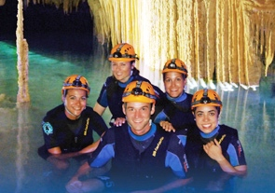
Date - Sunday, October 20, 2019
Price - 2 Adults $110.00 ea.

Transportation to & from your Hotel
Date - Sunday, October 20, 2019
Price - Included with hotel

Tulum Half Day Tour - Hotel Ground Transportation is Included
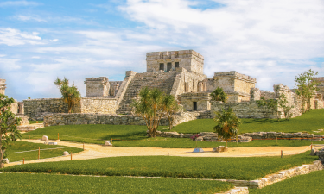
Date - Sunday, October 20, 2019
Price - 2 Adults $70.00 ea.

Xenotes Tour- Hotel Ground Transportation is Included
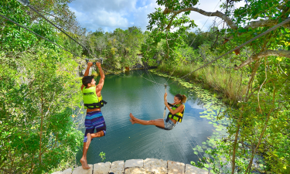
Date - Sunday, October 20, 2019
Price - 2 Adults $130.00 ea.

Summary

Flights & HotelPackage(includes Taxes and Carrier Imposed Fees) | $3,584.83

Adult Base Price (2) | $1,792.42

All-In-One Travel Protection | $ 261.98

Chichen Itza Deluxe - Hotel Ground Transportation is Included | $ 300.00

Rio Secreto - Hotel Ground Transportation is Included | $ 220.00

Tulum Half Day Tour - Hotel Ground Transportation is Included | $ 140.00

Xenotes Tour- Hotel Ground Transportation is Included | $ 260.00

Total Price | $4,766.81

Price per person | $2,383.41

Options | $ 1,181.98

