Travel Quote
Parents
Thank you for taking the time to price a Funjet Vacations getaway, where you'll Do Something You'll Never Forget, with UADVENTURE, LLC. This email is to notify you of the items you selected when working with Chuck Hermans from UADVENTURE, LLC. All prices listed may be subject to change until payment is received.
Consider upgrading your room for the best vacation experience!
Please review the Terms and Conditions.

Total Amount of Payments | USD $0.00
Balance Due | USD $2,353.49
Deposit Due on 22SEP19 | USD $250.00
Full Payment Due on 18JUL20 | USD $2,353.49

Flights - departing 01SEP20 and returning 05SEP20
Depart
Frontier Airlines #86 |  |  | Bulk Fare Coach Z
Leaves | Tuesday, September 1, 2020 | 6:30 AM | St. Louis (STL)
Arrives | Tuesday, September 1, 2020 | 9:51 AM | Cancun - Cancun AND Riviera Maya (CUN)
Exclusive Nonstop Vacation Flights

Additional baggage charges may apply
Return
Frontier Airlines #87 |  |  | Bulk Fare Coach Z
Leaves | Saturday, September 5, 2020 | 12:02 PM | Cancun - Cancun AND Riviera Maya (CUN)
Arrives | Saturday, September 5, 2020 | 3:17 PM | St. Louis (STL)
Exclusive Nonstop Vacation Flights

Additional baggage charges may apply
† indicates codeshare flight

Hotel - check in 01SEP20 and check out 05SEP20
Dreams Riviera Cancun Resort & Spa Unlimited - Luxury
- Location: Puerto Morelos
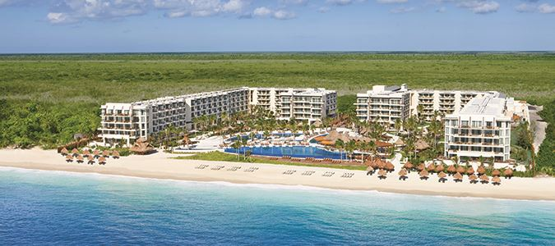Room 1 - 2 Adults
Room Type - Premium Deluxe Tropical & Gardenview
Save up to 57%! Book by Jun 17th! Exclusive Nonstop Vacation Flights
$200 in Resort Coupons
Guests will receive $200 in resort coupons per room per stay.
Important information: Resort Coupons cannot be applied toward the following items: beauty salon services, spa product purchases, telephone charges, gift shop purchases, boutique purchases, internet service, marina services, dive shop, medical services, car rentals and travel agency services. Resort Coupons must be redeemed at the time of reservation or service. Resort Coupons do not hold any cash or commercial value, are not refundable and non-transferable. They are not applicable for tips, taxes, private functions and/or special events such as Christmas and New Year's gala dinners. Resort Coupons are not accumulative and cannot be combined with any other promotion or special offer including, but not limited to spa treatment discounts. They are only valid during the original stay and cannot be deducted upon check out. Not combinable with other promotions or special offers. Restrictions and blackout dates apply. This entire offer is based on availability and can be modified or closed out at any time. Not applicable to group bookings. Other restrictions may apply. Redemption information will be provided upon check-in.
Complimentary Newlywed & Anniversary Package!
This complimentary package includes:
-Welcome letter
-Fresh fruit
-Bottle of sparkling wine
-Special turn down service
-Breakfast in bed with Mimosas (Reservations must be made in advance with concierge)
-15% discount on all spa treatments
To receive the offer, just enter "Newlyweds" or "Anniversary" in the Special Service Request section during check-out or call our Customer Care Center and we will be happy to make the notation for you.
Important Information: Couple will be required to present a copy of your wedding invitation or marriage certificate at check-in. 15% discount on spa treatments cannot be applied to spa packages or combined with any other spa promotion or offer. Travel must occur over anniversary date or within three months of wedding date.

Unlimited-Luxury Inclusions!
UNLIMITED - LUXURY® INCLUSIONS
- Limitless access to gourmet à la carte dining options without reservations required
- Unlimited international and domestic top-shelf spirits
- Unlimited natural fruit juices and soft drinks
- 24-hour room and concierge services
- Pool and beach wait service
- Daily refreshed mini-bar with soft drinks, juice, bottled water and beer
- Daily maid service
- Endless daytime activities and live nightly entertainment
- Theme parties, oceanfront bars and entertainment venues
- No wristbands required
- All taxes and gratuities
- Enjoy free Wi-Fi and free international calling to the US, Canada and local landlines with Unlimited Connectivity. The mobile app also allows guests to view the schedules of all events, activities and restaurants at the resort, plus to learn about local destinations, excursions, and much more.
Applicable promotions will display with your room selection. Some restrictions may apply.
Hotel Rating 5.0

Hotel Advisories
Student Groups (Spring Breakers) are not permitted at Hotel. A student group consist of those that travel without parent supervision or a responsible adult in each room. This could refer to but not limited to high school students or college students booking multiple rooms. The hotel reserves the right to deny lodging to any reservations of this type. Important Information For Our Guests Please be aware that due to changing weather and ocean conditions, beach shapes and characteristics may vary.

Add-ons - for 01SEP20 to 05SEP20
Fees Apply for Checked and Carry-On Bags
Date - Tuesday, September 1, 2020
Price - 1 Item $0.00 ea.

Identification Required For Travel
Date - Tuesday, September 1, 2020
Price - Included with hotel

Price Match Plus!
Date - Tuesday, September 1, 2020
Price - Included with hotel

Transportation to & from your Hotel with Complimentary Upgrade to Non-Stop Service
Date - Tuesday, September 1, 2020
Price - 2 Adults $30.00 ea.

Summary

Flights & Hotel Package (includes Taxes and Carrier Imposed Fees) | $2,293.49

Adult Base Price (2) | $1,146.75

Fees Apply for Checked and Carry-On Bags | $ 0.00

Transportation to & from your Hotel with Complimentary Upgrade to Non-Stop Service | $ 60.00

Total Price | $2,353.49

Options | $ 60.00

